Name: Richard Raymond J. Canda

C.Y.S.: BSCpE - 3A

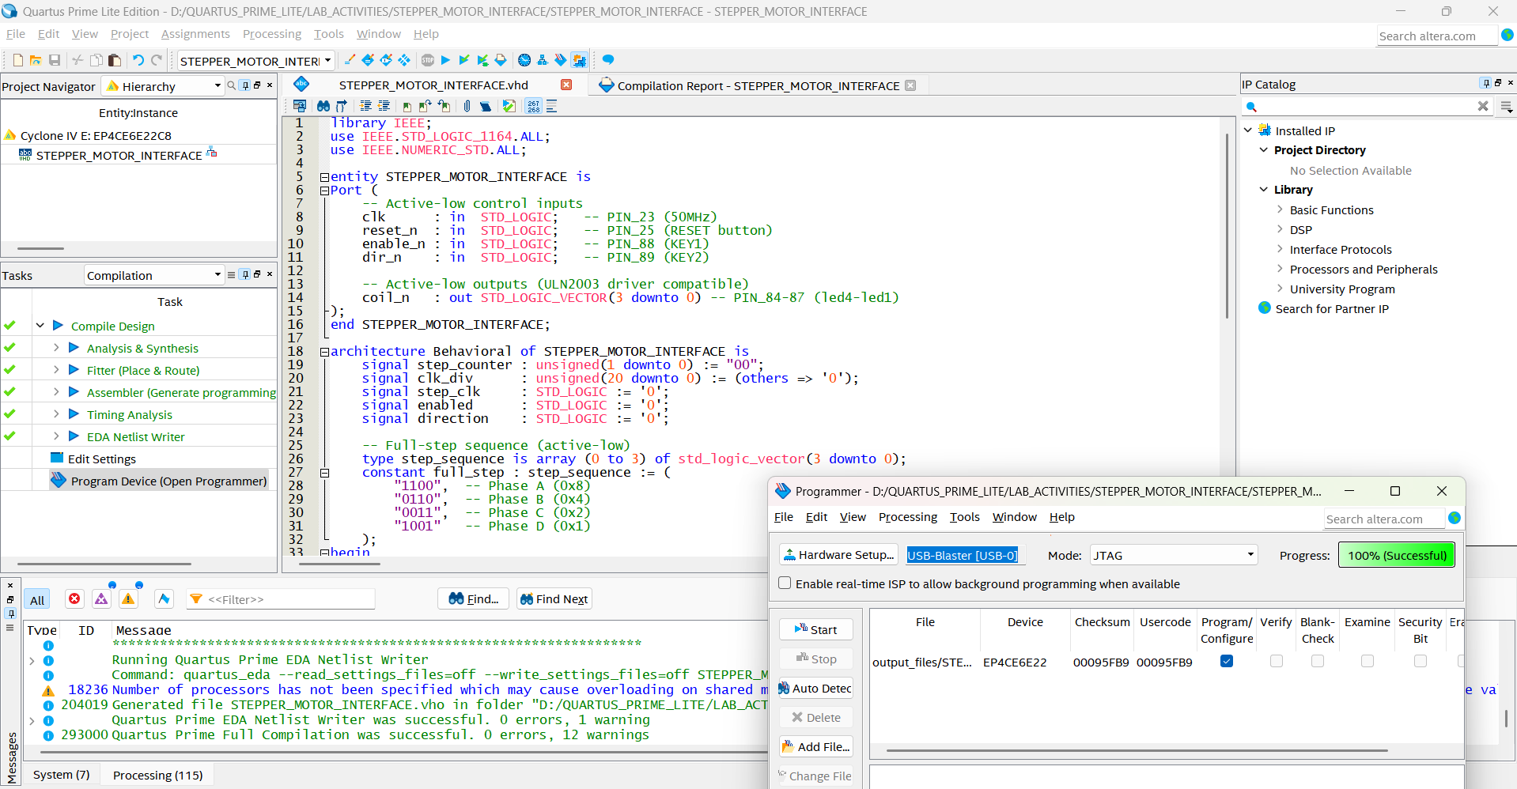

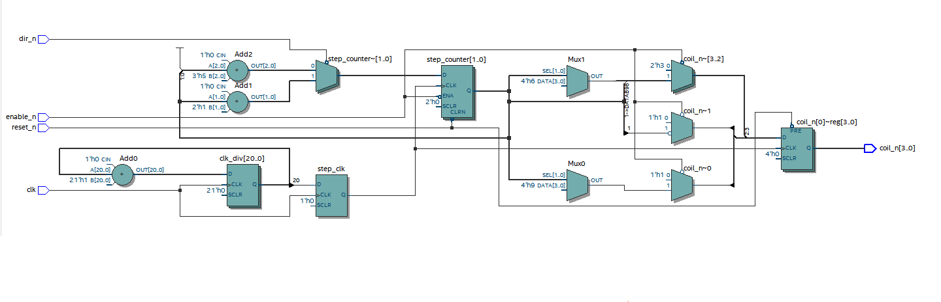

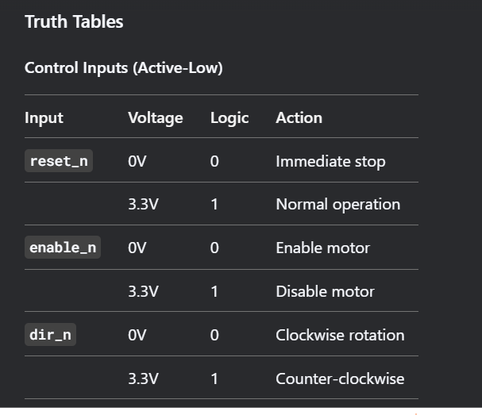

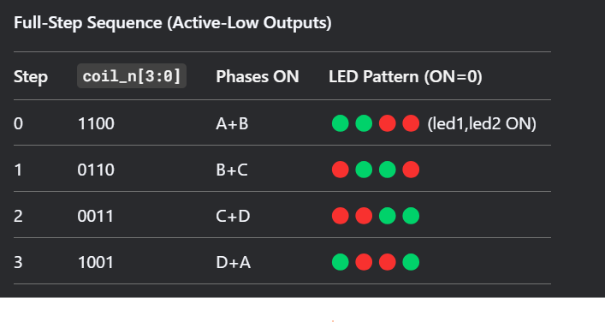

**VHDL CODE FOR STEPPER MOTOR INTERFACE**

library IEEE;

use IEEE.STD_LOGIC_1164.ALL;

use IEEE.NUMERIC_STD.ALL;

entity STEPPER_MOTOR_INTERFACE is

Port (

-- Active-low control inputs

clk : in STD_LOGIC; -- PIN_23 (50MHz)

reset_n : in STD_LOGIC; -- PIN_25 (RESET button)

enable_n : in STD_LOGIC; -- PIN_88 (KEY1)

dir_n : in STD_LOGIC; -- PIN_89 (KEY2)

-- Active-low outputs (ULN2003 driver compatible)

coil_n : out STD_LOGIC_VECTOR(3 downto 0) -- PIN_84-87 (led4-led1)

);

end STEPPER_MOTOR_INTERFACE;

architecture Behavioral of STEPPER_MOTOR_INTERFACE is

signal step_counter : unsigned(1 downto 0) := "00";

signal clk_div : unsigned(20 downto 0) := (others => '0');

signal step_clk : STD_LOGIC := '0';

signal enabled : STD_LOGIC := '0';

signal direction : STD_LOGIC := '0';

-- Full-step sequence (active-low)

type step_sequence is array (0 to 3) of std_logic_vector(3 downto 0);

constant full_step : step_sequence := (

"1100", -- Phase A (0x8)

"0110", -- Phase B (0x4)

"0011", -- Phase C (0x2)

"1001" -- Phase D (0x1)

);

begin

-- Clock divider (50MHz → ~12Hz stepping)

process(clk)

begin

if rising_edge(clk) then

clk_div <= clk_div + 1;

step_clk <= clk_div(20); -- 50MHz/2^21 ≈ 12Hz

end if;

end process;

-- Stepping control

process(step_clk, reset_n)

begin

if reset_n = '0' then

step_counter <= "00";

coil_n <= "1111"; -- All coils OFF (active-low)

elsif rising_edge(step_clk) then

if enabled = '1' then

if direction = '1' then

step_counter <= step_counter + 1; -- CW

else

step_counter <= step_counter - 1; -- CCW

end if;

-- Output current step phase (active-low)

coil_n <= full_step(to_integer(step_counter));

else

coil_n <= "1111"; -- Disable all coils

end if;

end if;

end process;

-- Control signal processing (active-low to active-high)

enabled <= not enable_n;

direction <= not dir_n;

end Behavioral;

